

**2024 Summer Camp Application**

**June 10 – July 26, 2024**

**Hours: 07:30am to 06:00pm**

**Race**

* American Indian or Alaska Native
* Asian
* Black or African American
* Middle Eastern or North African
* Native Hawaiian or Pacific Islander
* White
* Other _________________
* Bi-Racial
* Multi-Racial
* Prefer Not to Answer

**Pronouns** □ He/Him □ She/Her □ They/them □ Other (please list):

**Gender/Sex** □ Male □ Trans Male □ Non-binary □ Gender Non-Conforming □ Other

□ Female □ Trans Female □ Gender Queer □ Agender □ Prefer not to answer

First Name _____________________________________________________________________________

Middle Name _____________________________________________________________________________

Last Name _____________________________________________________________________________

Date of Birth _____________________________________________________________________________

Address _____________________________________________________________________________

City, State ______________________________________________ Zip Code ______________________

Who has primary custody of the member? _____________________________________________________________

Total years of membership ________ Name(s) of Clubs Attended ­­­­­­__________________________________________

**Member Information**

Date _______________________

**Member Type** □ New Member □ Renewing Member

**Swimming:**

Can member swim? □ Yes □ No

**Pick Up from Club:**

□ Walking home alone (must be 14+) □ Picked up by authorized contact

**Ethnicity** □ Hispanic/Latino □ Non-Hispanic/Latino

**T-Shirt Size:**  □ Youth XS □ Youth S □ Youth M □ Youth L □ Youth XL

□ Adult XS □ Adult S □ Adult M □ Adult L □ Adult XL

**Authorized Contact 1**

Full Name ________________________________

Primary Phone ________________________________

Secondary Phone _______________________________

Emergency Contact □ Yes □ No

Allowed to pick member up □ Yes □ No

**Relationship:**

* Parent
* Step-Parent
* Grandparent
* Aunt/Uncle
* Neighbor
* Sibling (must be 14+)
* Other Adult
* Case Worker
* Foster Parent

**Authorized Contact 2**

Full Name ________________________________

Primary Phone ________________________________

Secondary Phone _______________________________

Emergency Contact □ Yes □ No

Allowed to pick member up □ Yes □ No

**Authorized Contacts**

**Primary Contact**

**Relationship to** □ Parent □ Step-Parent □ Grandparent □ Sibling (must be 14 or older)

**Member** □ Aunt/Uncle □ Foster Parent □ Case Worker □ Other Guardian/ Relative/Trusted Adult

First Name _____________________________________________________________________________

Last Name _____________________________________________________________________________

Employer _____________________________________________________________________________

Email _____________________________________________________________________________

Address _____________________________________________________________________________

City, State ______________________________________________ Zip Code ______________________

Primary Phone ________________________________ Other phone ________________________________



* Sibling (must be 14+)
* Other Adult
* Case Worker
* Foster Parent
* Parent
* Step-Parent
* Grandparent
* Aunt/Uncle
* Neighbor

**Add additional contacts that are authorized below:**

**Unauthorized Contacts**

These are individuals who are not allowed to come in contact with your member. They will not be allowed to enter the Club. If the call or show up asking about your member or any other members of your family or household, they will be told that “we cannot confirm or deny that person is involved in any way with our Club.” If someone on this list shows up to pick up your member, they will not be allowed to do so. You must come in person to remove someone from your unauthorized contact list.

**Unauthorized Contact 2**

Full Name ___________________________________

Phone ___________________________________

Start Date ___________________________________

End Date ___________________________________

**Relationship:**

**Unauthorized Contact 1**

Full Name ___________________________________

Phone ___________________________________

Start Date ___________________________________

End Date ___________________________________

**Relationship:**

* Sibling
* Other Adult
* Case Worker
* Foster Parent
* Parent
* Step-Parent
* Grandparent
* Aunt/Uncle
* Neighbor
* Sibling
* Other Adult
* Case Worker
* Foster Parent
* Parent
* Step-Parent
* Grandparent
* Aunt/Uncle
* Neighbor

**Add additional unauthorized contacts or any information Club staff should know about unauthorized contacts below:**

**Diagnosed**

**Medical**

**Conditions**

* Asthma
* ADD/ADHD
* Anxiety
* Autism
* Depression
* Diabetes
* Hearing Impairment
* ODD
* Seizures
* Skin Condition
* Speech Issues
* Visual Impairment
* Other (please list):

**Medical Information**

** **

**Medical Information**

**Does the member use any of the following?**

□ Inhaler □ Insulin □ EpiPen □ Hearing Aid □ Speech/Communication Device

□ Glasses/Visual Aid □ Wheelchair □ Other Mobility Device □ Self-administered medication

□ Other (please list):

**Does the member require any special accommodations to receive services?** □ Yes □ No

**If yes, describe:**



**Please describe any other important details/information regarding diagnosis, medication (only as it involves behavior or taking medicine during club hours), behavior, or any other physical/mental/medical limitations:**



**BLANKET FIELD TRIP PERMISSION SLIP**

2024 Summer Camp

To All Parents:

This is a blanket permission slip to cover all field trips taken during regular Club hours. I understand that throughout summer camp my child may have an opportunity to participate in trips that will take them away from the official Club location. I also realize these trips will be under the direct supervision of BGC of Greater Peoria staff. Therefore, for the current summer, I give permission for my child to participate in designated Club-sponsored field trips.

Notices describing each individual trip will be sent home prior to each field trip. If there is a specific trip you do not wish your child to participate in you may notify the Site Director at that time. In the event of a last-minute addition or change to a field trip, BGC of Greater Peoria staff will notify the person listed as each child’s primary contact on their membership application.

The undersigned agrees to release, hold harmless, and indemnify Boys & Girls Clubs of Greater Peoria, its agents, representatives, and employees from all claims, damages, or other liabilities for injuries to my child which are not the result of gross negligence, intentional neglect, or willful or wanton conduct by the Club, or its agents, representatives, or employees.

In the event of an emergency, a staff member will refer to the emergency contact information provided in the child’s membership application. I authorize any medical treatment in case of an emergency, and agree that I am responsible for the cost of such treatment. As such, it is the responsibility of the student’s parent/guardian to update this information while completing the annual registration documents. Please contact the Site Director directly if pertinent medical information must be submitted or updated in order for your child to participate in one of the trips.

Name of Participant: ____________________________________________________

Name of Parent/Guardian: _______________________________________________

Signature of Parent/Guardian: ____________________________________________

Date: ________________________________________________________________

**WAIVERS & RELEASES**

**Data Collection**

□ Yes □ No

I give my permission to the BGC of Greater Peoria to collect information via online or written surveys, questionnaires, interviews and focus groups from the minor child listed on this application. Any and all information received will be kept strictly confidential. Data gathered through these means will be summarized in the aggregate and will exclude all references to any individual responses. The aggregated results of these analyses may be shared with Club staff, BGCA, funders, and other community stakeholders to evidence program effectiveness and/or Club impact on our members. This release may be revoked at any time by contacting the BGC of Greater Peoria in writing.

I understand that the Boys & Girls Club of Greater Peoria is not responsible for lost or stolen items. Each Club has the right to make membership decisions based on the resources and capacity of their facility and staff. BGC of Greater Peoria reserves the right to decline the application, rescind the enrollment of, or suspend any youth that cannot successfully associate with other club members.

**Miscellaneous**

□ Yes □ No

**Press/Media**

□ Yes □ No

I give my permission for my child's picture, video image, or any other graphic depiction or likeness, to be used by BGC of Greater Peoria, Boys & Girls Clubs of America and its affiliates or donors and acknowledge neither my child nor I will receive payment for same.

**Data Sharing**

□ Yes □ No

I give my permission to the BGC of Greater Peoria to share information about the minor child listed on this application with BGCA for research purposes and/or to evaluate the program's effectiveness. Information that will be disclosed to BGCA may include the information provided on this membership application form, information provided by the minor child's school or school district, and other information collected by BGC of Greater Peoria, including data collected via surveys or questionnaires. All information provided to BGCA will be kept confidential. This release may be revoked at any time by contacting the BGC of Greater Peoria in writing.

**Transportation**

□ Yes □ No

Parents and Club members may be responsible for their own transportation to and from the Club, unless otherwise specified

**Technology**

□ Yes □ No

As a member of theBoys & Girls Club of Greater Peoria, our child may have access to the internet. While the Boys & Girls Club of Greater Peoria has rules prohibiting such conduct and precautions are taken by the Club to prevent such access, it is possibly your child may access inappropriate sites. The Boys & Girls Club of Greater Peoria will not be responsible for such unauthorized access

**Medical**

□ Yes □ No

I give permission to the BGC of Greater Peoria to seek emergency medical treatment for my minor child if I cannot be reached. I will be responsible for any/all costs of medical attention and treatment.

**Teen REACH Screening Sheet – required for members of all ages**

Is the member considered a Senior in High School for the 2024-2025 school year? □ Yes □ No

Is the member living in a single parent household? □ Yes □ No

Does the member reside in a household receiving TANF? □ Yes □ No

Does the member have any current academic difficulties? □ Yes □ No

Is the member at risk of being held back to repeat a grade level? □ Yes □ No

Has the member been held back to repeat a grade level previously? □ Yes □ No

Does the member have a record of truancy or chronic absenteeism? □ Yes □ No

Does the member have any reported behavior issues? □ Yes □ No

Has the member been a victim of bullying? □ Yes □ No

Has the member been a perpetrator of bullying? □ Yes □ No

Before joining the Club, has the member been unsupervised after school? □ Yes □ No

Has the member witnessed or been a victim of family violence? □ Yes □ No

Does the member identify as LGBTQ? □ Yes □ No

Have any of the member’s siblings dropped out of school? □ Yes □ No

Are any of the member’s siblings teen parents? □ Yes □ No

Are any of the member’s siblings involved in the juvenile justice system? □ Yes □ No

Are one or both of the member’s parents incarcerated? □ Yes □ No

Are any of the member’s siblings gang involved? □ Yes □ No

Is the member involved in any gang activity? □ Yes □ No

Is the member in the DCFS system? □ Yes □ No

Is the member homeless? □ Yes □ No

Is the member pregnant? □ Yes □ No

Is the member a parent? □ Yes □ No

*Our program receives funding from a program called Teen REACH (Responsibility, Education, Achievement, Caring, and Hope) and is therefore required to ask the following screening questions for reporting purposes. Answers are for demographic information only and will not affect the youth’s ability to participate in the Club.*

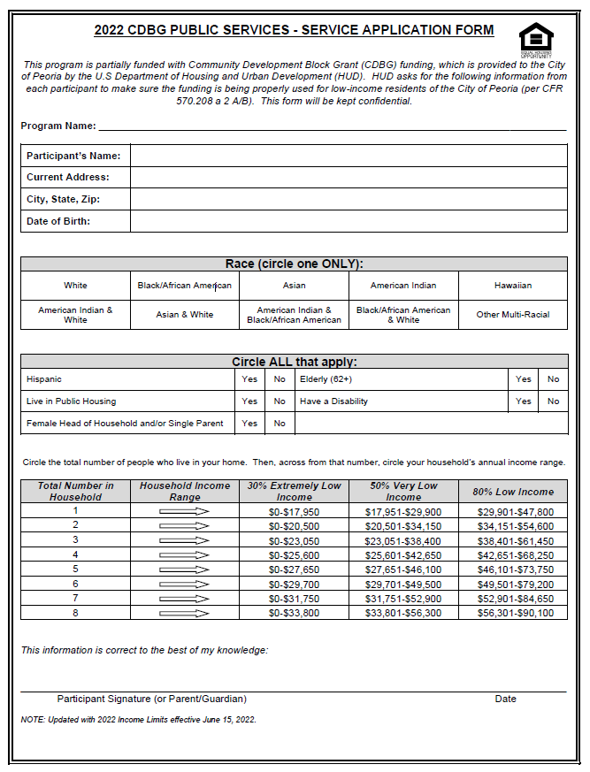

I understand the BGC of Greater Peoria has an open-door policy where members are allowed to come and go as they please. Should a member leave the Club, they will not be granted return access unless approved by the Club Director. We assume no responsibility for members who choose not to attend on a particular day or who choose to leave early.

I, the parent/guardian of the minor child listed on this application, on behalf of the minor child listed herein and for ourselves, our heirs, executors and administrators, hereby release, waive, acquit and forever discharge the Boys & Girls Clubs of Greater Peoria and Boys & Girls Clubs of America (BGCA), their representatives, successors, insurers, assigns or any other person or entity associated with any of the above organizations such as staff, directors or volunteers, from all liability, claims, demands, or causes of action for any and all loss, damage, injury or death and any claim of damages resulting from use of facilities owned or controlled by the above organizations, or participation in activities of said organizations either at or away from the Club.

*Your signature below confirms that all information above is true and accurate.*

_____________________________________________________________ _____________________

Parent/Guardian Signature Date

**APPLICATION APPROVAL**